

Project Report
Introduction to Data Science – II
company_esg_financial_dataset.
By
Shivam patel
Reg No.2411021240016
Department of Computer Application Alliance University
Chandpur — Anekal Main Road, Anekal Bengaluru — 562106

April 2025
Sure! Here's a simpler, more straightforward version:

In today’s business world, making smart and sustainable decisions means understanding both the financial performance and the environmental, social, and governance (ESG) efforts of companies. This project looks at a large dataset that includes financial details and ESG scores for different companies over time. The main goal is to find patterns in revenue, market value, and profit margins across different industries and regions, and to get a better idea of how companies are spread out and how financially healthy they are.

The project began by importing the dataset using Python's Pandas library. Data preprocessing steps included checking for missing values, identifying duplicated records, and understanding the data structure using statistical summaries.
Following this, several visualizations were created to uncover patterns:
A line plot showing revenue trends over the years for different companies
A bar chart representing the number of companies in each industry
A region-wise bar chart to explore geographic distribution
A bubble scatter plot mapping MarketCap vs Revenue, with bubble sizes representing profit margins
Splitting the data into training and testing sets (80-20 split)
Evaluating model performance using R² Score and Mean Absolute Error (MAE)
These visualizations were created using Seaborn and Matplotlib, which allowed for clear, insightful graphical representation of the data

Descriptive details
The charts and analysis gave useful insights into how companies are spread out and performing across different industries and regions. Some industries and areas had a lot more companies, while others had fewer. The bubble chart showed how revenue relates to market value and also revealed that profit margins differ between sectors. Overall, the project shows that combining financial and ESG (Environmental, Social, and Governance) data with clear visuals can help people better understand the business landscape and make smarter decisions.

GitHub LINK: https://github.com/shivam88309/IDS-ASSINGMENT/upload/main

# Import required libraries
import pandas as pd
import numpy as np
import seaborn as sns
import matplotlib.pyplot as plt
import warnings
# Load the dataset
shivam= pd.read_csv("E:\company_esg_financial_dataset.csv")
shivam
<>:9: SyntaxWarning: invalid escape sequence '\c'
<>:9: SyntaxWarning: invalid escape sequence '\c'
C:\Users\gadar\AppData\Local\Temp\ipykernel_8144\3453169719.py:9: SyntaxWarning: invalid escape sequence '\c'
shivam = pd.read_csv("E:\company_esg_financial_dataset.csv")
CompanyID CompanyName Industry Region Year Revenue \
0 1 Company_1 Retail Latin America 2015 459.2
1 1 Company_1 Retail Latin America 2016 473.8
2 1 Company_1 Retail Latin America 2017 564.9
3 1 Company_1 Retail Latin America 2018 558.4
4 1 Company_1 Retail Latin America 2019 554.5
... ... ... ... ... ... ...
10995 1000 Company_1000 Consumer Goods Latin America 2021 3419.2
10996 1000 Company_1000 Consumer Goods Latin America 2022 3518.8
10997 1000 Company_1000 Consumer Goods Latin America 2023 3417.1
10998 1000 Company_1000 Consumer Goods Latin America 2024 3183.2
10999 1000 Company_1000 Consumer Goods Latin America 2025 3173.5
ProfitMargin MarketCap GrowthRate ESG_Overall ESG_Environmental \
0 6.0 337.5 NaN 57.0 60.7
1 4.6 366.6 3.2 56.7 58.9
2 5.2 313.4 19.2 56.5 57.6
3 4.3 283.0 -1.1 58.0 62.3
4 4.9 538.1 -0.7 56.6 63.7
... ... ... ... ... ...
10995 21.7 14416.7 0.4 52.2 67.2
10996 21.4 8078.9 2.9 51.9 68.7
10997 17.1 13263.4 -2.9 52.9 72.4
10998 15.7 6960.1 -6.8 52.0 72.4
10999 17.5 5666.1 -0.3 51.8 74.5
ESG_Social ESG_Governance CarbonEmissions WaterUsage \
0 33.5 76.8 35577.4 17788.7
1 32.8 78.5 37314.7 18657.4
2 34.0 77.8 45006.4 22503.2
3 33.4 78.3 42650.1 21325.1
4 30.0 76.1 41799.4 20899.7
... ... ... ... ...
10995 46.3 43.1 498875.8 623594.7
10996 44.7 42.3 506013.7 632517.1
10997 43.1 43.2 473561.5 591951.9
10998 40.5 42.9 441310.9 551638.6
10999 39.7 41.4 430741.6 538427.0
EnergyConsumption
0 71154.7
1 74629.4
2 90012.9
3 85300.2
4 83598.8
... ...
10995 2494378.8
10996 2530068.4
10997 2367807.7
10998 2206554.3
10999 2153707.9
[11000 rows x 16 columns]
# Display the first few rows
shivam.head()
CompanyID CompanyName Industry Region Year Revenue ProfitMargin \
0 1 Company_1 Retail Latin America 2015 459.2 6.0
1 1 Company_1 Retail Latin America 2016 473.8 4.6
2 1 Company_1 Retail Latin America 2017 564.9 5.2
3 1 Company_1 Retail Latin America 2018 558.4 4.3
4 1 Company_1 Retail Latin America 2019 554.5 4.9
MarketCap GrowthRate ESG_Overall ESG_Environmental ESG_Social \
0 337.5 NaN 57.0 60.7 33.5
1 366.6 3.2 56.7 58.9 32.8
2 313.4 19.2 56.5 57.6 34.0
3 283.0 -1.1 58.0 62.3 33.4
4 538.1 -0.7 56.6 63.7 30.0
ESG_Governance CarbonEmissions WaterUsage EnergyConsumption
0 76.8 35577.4 17788.7 71154.7
1 78.5 37314.7 18657.4 74629.4
2 77.8 45006.4 22503.2 90012.9
3 78.3 42650.1 21325.1 85300.2
4 76.1 41799.4 20899.7 83598.8
# Check for missing values
shivam.isnull().sum()
CompanyID 0
CompanyName 0
Industry 0
Region 0
Year 0
Revenue 0
ProfitMargin 0
MarketCap 0
GrowthRate 1000
ESG_Overall 0
ESG_Environmental 0
ESG_Social 0
ESG_Governance 0
CarbonEmissions 0
WaterUsage 0
EnergyConsumption 0
dtype: int64
# Data types and structure
shivam.info()
<class 'pandas.core.frame.DataFrame'>
RangeIndex: 11000 entries, 0 to 10999
Data columns (total 16 columns):
# Column Non-Null Count Dtype
--- ------ -------------- -----
0 CompanyID 11000 non-null int64
1 CompanyName 11000 non-null object
2 Industry 11000 non-null object
3 Region 11000 non-null object
4 Year 11000 non-null int64
5 Revenue 11000 non-null float64
6 ProfitMargin 11000 non-null float64
7 MarketCap 11000 non-null float64
8 GrowthRate 10000 non-null float64
9 ESG_Overall 11000 non-null float64
10 ESG_Environmental 11000 non-null float64
11 ESG_Social 11000 non-null float64
12 ESG_Governance 11000 non-null float64
13 CarbonEmissions 11000 non-null float64
14 WaterUsage 11000 non-null float64
15 EnergyConsumption 11000 non-null float64
dtypes: float64(11), int64(2), object(3)
memory usage: 1.3+ MB
# Statistical summary
shivam.describe()
CompanyID Year Revenue ProfitMargin MarketCap \
count 11000.000000 11000.000000 11000.000000 11000.000000 11000.000000
mean 500.500000 2020.000000 4670.850591 10.900455 13380.622236
std 288.688113 3.162421 9969.954369 8.758711 39922.870373
min 1.000000 2015.000000 35.900000 -20.000000 1.800000
25% 250.750000 2017.000000 938.775000 5.300000 1098.525000
50% 500.500000 2020.000000 1902.300000 10.500000 3096.450000
75% 750.250000 2023.000000 4342.625000 16.300000 9995.500000
max 1000.000000 2025.000000 180810.400000 50.000000 865271.700000
GrowthRate ESG_Overall ESG_Environmental ESG_Social \
count 10000.000000 11000.000000 11000.000000 11000.000000
mean 4.830370 54.615273 56.416991 55.660582
std 9.424787 15.893937 26.767233 23.356152
min -36.000000 6.300000 0.000000 0.000000
25% -1.325000 44.100000 34.700000 37.600000
50% 4.900000 54.600000 55.600000 55.150000
75% 11.000000 65.600000 79.000000 73.800000
max 38.000000 98.800000 100.000000 100.000000
ESG_Governance CarbonEmissions WaterUsage EnergyConsumption
count 11000.000000 1.100000e+04 1.100000e+04 1.100000e+04
mean 51.767655 1.271462e+06 5.600442e+05 1.165839e+07
std 25.323370 5.067760e+06 1.565686e+06 5.095836e+07
min 0.000000 2.042200e+03 1.021100e+03 5.105500e+03
25% 30.775000 1.228530e+05 6.488467e+04 3.069161e+05
50% 52.100000 2.920734e+05 2.038805e+05 1.221745e+06
75% 73.000000 7.407311e+05 5.251880e+05 5.616437e+06
max 100.000000 1.741047e+08 5.223142e+07 1.741047e+09
shivam.describe
<bound method NDFrame.describe of CompanyID CompanyName Industry Region Year Revenue \
0 1 Company_1 Retail Latin America 2015 459.2
1 1 Company_1 Retail Latin America 2016 473.8
2 1 Company_1 Retail Latin America 2017 564.9
3 1 Company_1 Retail Latin America 2018 558.4
4 1 Company_1 Retail Latin America 2019 554.5
... ... ... ... ... ... ...
10995 1000 Company_1000 Consumer Goods Latin America 2021 3419.2
10996 1000 Company_1000 Consumer Goods Latin America 2022 3518.8
10997 1000 Company_1000 Consumer Goods Latin America 2023 3417.1
10998 1000 Company_1000 Consumer Goods Latin America 2024 3183.2
10999 1000 Company_1000 Consumer Goods Latin America 2025 3173.5
ProfitMargin MarketCap GrowthRate ESG_Overall ESG_Environmental \
0 6.0 337.5 NaN 57.0 60.7
1 4.6 366.6 3.2 56.7 58.9
2 5.2 313.4 19.2 56.5 57.6
3 4.3 283.0 -1.1 58.0 62.3
4 4.9 538.1 -0.7 56.6 63.7
... ... ... ... ... ...
10995 21.7 14416.7 0.4 52.2 67.2
10996 21.4 8078.9 2.9 51.9 68.7
10997 17.1 13263.4 -2.9 52.9 72.4
10998 15.7 6960.1 -6.8 52.0 72.4
10999 17.5 5666.1 -0.3 51.8 74.5
ESG_Social ESG_Governance CarbonEmissions WaterUsage \
0 33.5 76.8 35577.4 17788.7
1 32.8 78.5 37314.7 18657.4
2 34.0 77.8 45006.4 22503.2
3 33.4 78.3 42650.1 21325.1
4 30.0 76.1 41799.4 20899.7
... ... ... ... ...
10995 46.3 43.1 498875.8 623594.7
10996 44.7 42.3 506013.7 632517.1
10997 43.1 43.2 473561.5 591951.9
10998 40.5 42.9 441310.9 551638.6
10999 39.7 41.4 430741.6 538427.0
EnergyConsumption
0 71154.7
1 74629.4
2 90012.9
3 85300.2
4 83598.8
... ...
10995 2494378.8
10996 2530068.4
10997 2367807.7
10998 2206554.3
10999 2153707.9
[11000 rows x 16 columns]>
shivam.duplicated().sum()
0
shivam.shape
(11000, 16)
shivam.dtypes
CompanyID int64
CompanyName object
Industry object
Region object
Year int64
Revenue float64
ProfitMargin float64
MarketCap float64
GrowthRate float64
ESG_Overall float64
ESG_Environmental float64
ESG_Social float64
ESG_Governance float64
CarbonEmissions float64
WaterUsage float64
EnergyConsumption float64
dtype: object
shivam.columns
Index(['CompanyID', 'CompanyName', 'Industry', 'Region', 'Year', 'Revenue',
'ProfitMargin', 'MarketCap', 'GrowthRate', 'ESG_Overall',
'ESG_Environmental', 'ESG_Social', 'ESG_Governance', 'CarbonEmissions',
'WaterUsage', 'EnergyConsumption'],
dtype='object')
DATA VISUALIZATIONs
plt.figure(figsize=(12, 6))
sns.lineplot(data=shivam, x='Year', y='Revenue', hue='CompanyName', marker='o')
plt.title('Revenue Over Time by Company')
plt.ylabel('Revenue')
plt.xticks(rotation=45)
plt.tight_layout()
plt.show()
C:\Users\gadar\AppData\Local\Temp\ipykernel_12400\2177575422.py:6: UserWarning: Tight layout not applied. The bottom and top margins cannot be made large enough to accommodate all Axes decorations.
plt.tight_layout()
# Industry Distribution
plt.figure(figsize=(10, 5))
shivam['Industry'].value_counts().plot(kind='barh', color='maroon')
plt.title('Number of Companies per Industry')
plt.xlabel('Count')
plt.tight_layout()
plt.show()
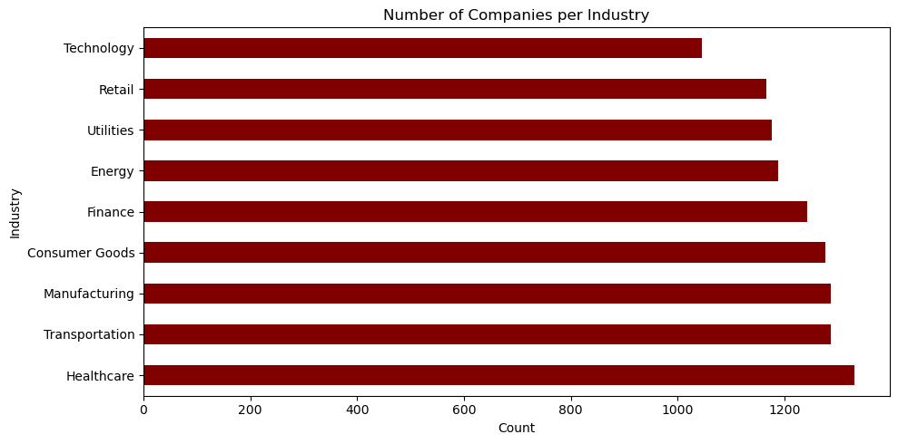
# Region-wise Company Distribution
plt.figure(figsize=(10, 5))
shivam['Region'].value_counts().plot(kind='bar', color='blue')
plt.title('Number of Companies per Region')
plt.ylabel('Count')
plt.tight_layout()
plt.show()
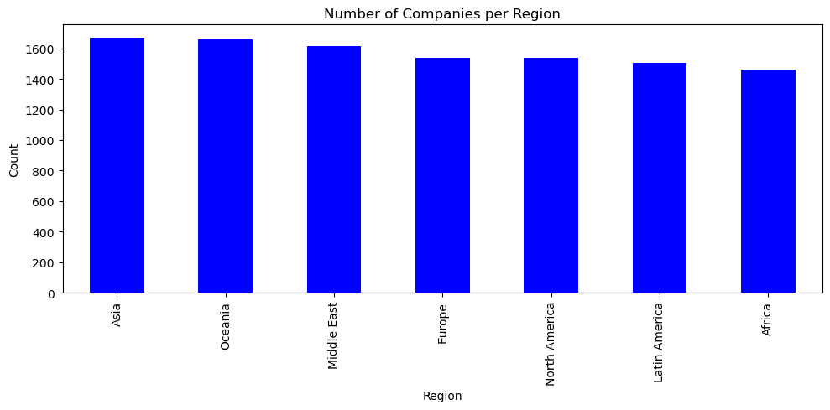
plt.figure(figsize=(10, 6))
sns.scatterplot(data=shivam, x='Revenue', y='MarketCap', hue='Industry',
size='ProfitMargin', sizes=(40, 400), alpha=0.7)
plt.title('MarketCap vs Revenue (Bubble = ProfitMargin)')
plt.tight_layout()
plt.show()
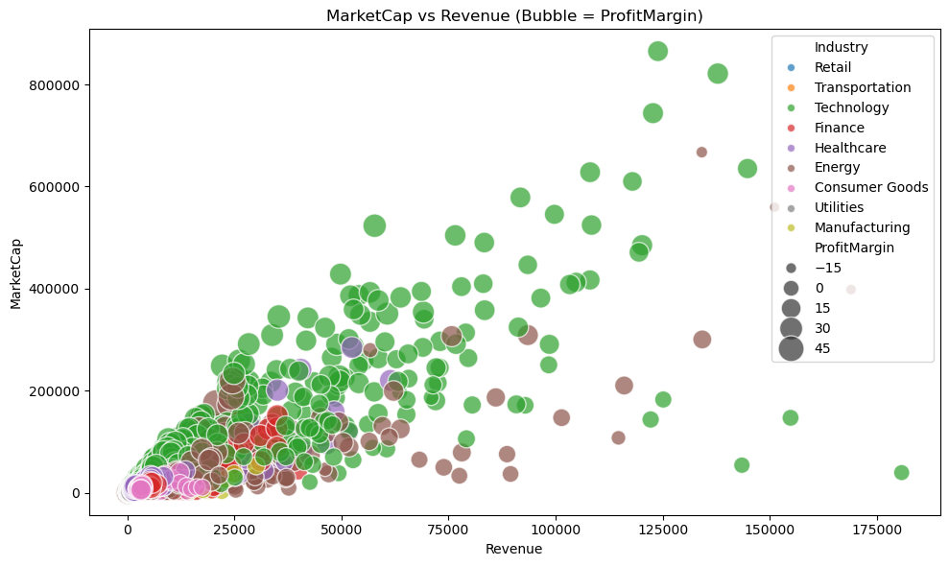
import seaborn as sns
import matplotlib.pyplot as plt
# Select numeric columns from your dataframe
sns.pairplot(shivam[["Revenue", "ProfitMargin", "MarketCap", "GrowthRate"]])
plt.show()
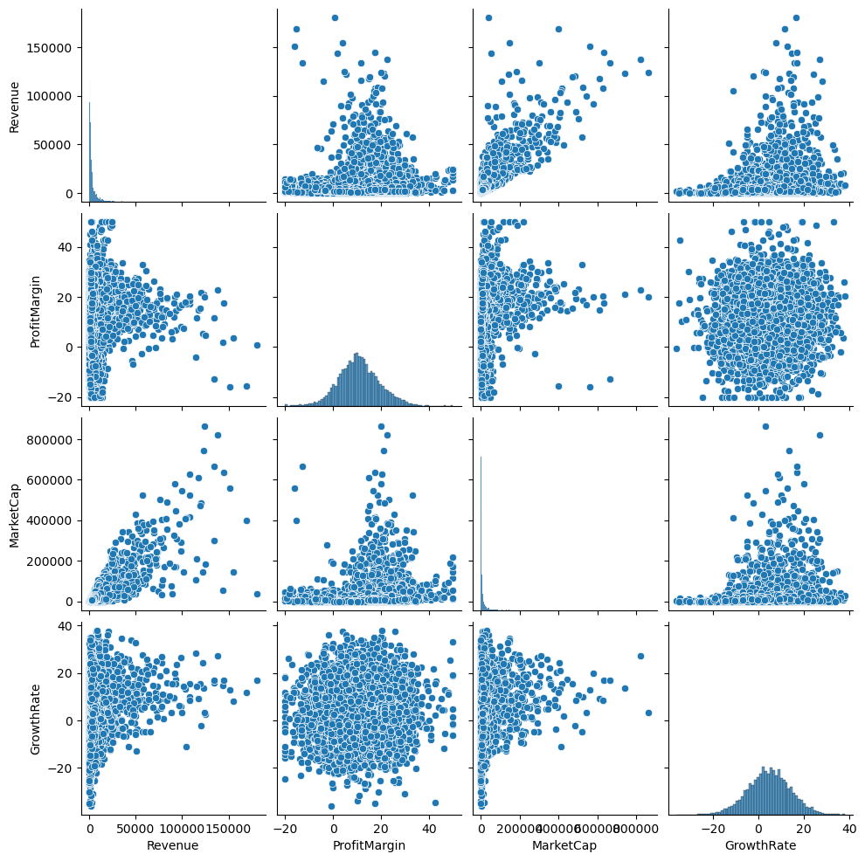
# Distribution of ESG Overall Score
plt.figure(figsize=(8, 5))
sns.histplot(shivam['ESG_Overall'], kde=True, bins=20, color='blue')
plt.title('Distribution of ESG Overall Score')
plt.tight_layout()
plt.show()
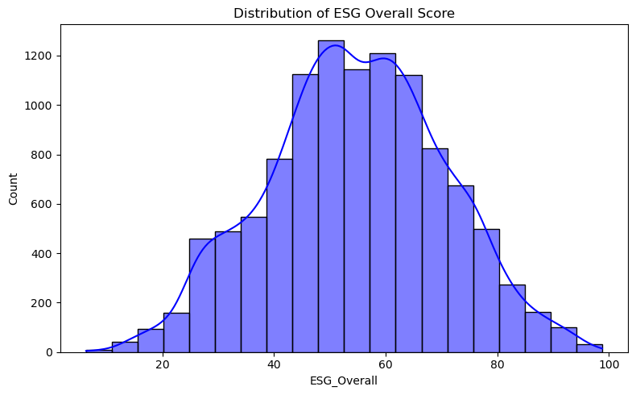
# ESG Scores by Industry
# Boxplot - To detect Outliers
plt.figure(figsize=(12, 6))
sns.boxplot(data=shivam, x='Industry', y='ESG_Overall')
plt.title('ESG Overall Score by Industry')
plt.xticks(rotation=45)
plt.tight_layout()
plt.show()
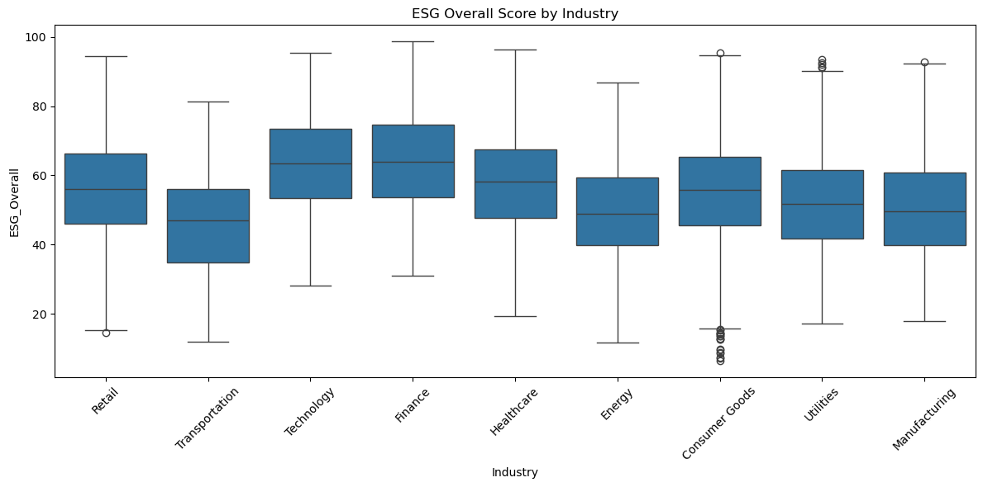
🧪 Hypothesis Testing Q: Do Action movies have a higher average rating than Drama movies? We'll use a two-sample t-test.
# Outlier Detection using IQR method
import pandas as pd
# Select only numeric columns for IQR outlier detection
numeric_df = shivam.select_dtypes(exclude="object")
# Compute Q1, Q3, and IQR
Q1 = numeric_df.quantile(0.25)
Q3 = numeric_df.quantile(0.75)
IQR = Q3 - Q1
# Filter out outliers
shivam _no_outliers = shivam [~((numeric_df < (Q1 - 1.5 * IQR)) |
(numeric_df > (Q3 + 1.5 * IQR))).any(axis=1)]
# Check how many rows were removed
print(f"Original rows: {.shape[0]}")
print(f"After outlier removal: { shivam _no_outliers.shape[0]}")
Original rows: 11000
After outlier removal: 8116
# Carbon Emissions vs Revenue
plt.figure(figsize=(10, 6))
sns.scatterplot(data=shivam, x='CarbonEmissions', y='Revenue', hue='Industry')
plt.title('Carbon Emissions vs Revenue')
plt.xscale('log') # If needed due to skew
plt.tight_layout()
plt.show()
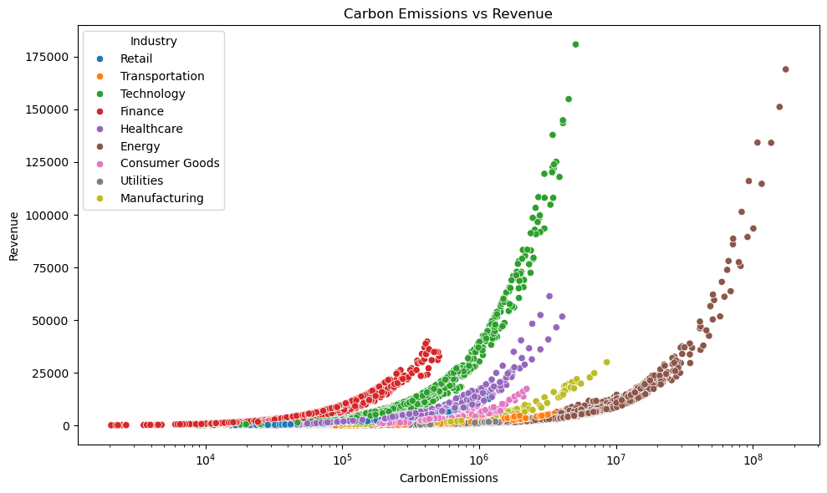
# Boxplot - To detect Outliers
# Energy Consumption by Region
plt.figure(figsize=(10, 6))
sns.boxplot(data=shivam, x='Region', y='EnergyConsumption')
plt.title('Energy Consumption by Region')
plt.xticks(rotation=45)
plt.tight_layout()
plt.show()
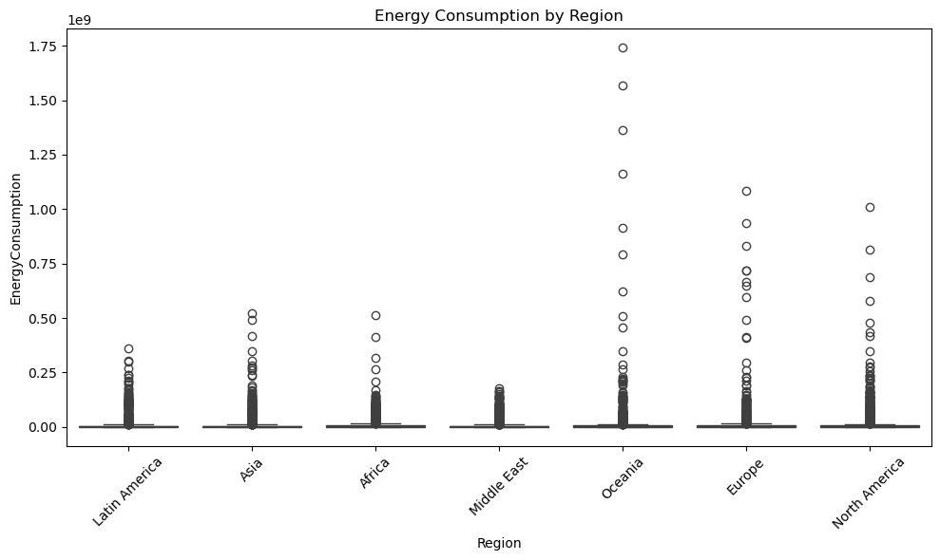
#correlation heatmap
plt.figure(figsize=(12, 8))
corr_matrix = shivam.corr(numeric_only=True)
sns.heatmap(corr_matrix, annot=True, cmap='coolwarm', fmt='.2f')
plt.title('Correlation Heatmap')
plt.tight_layout()
plt.show()
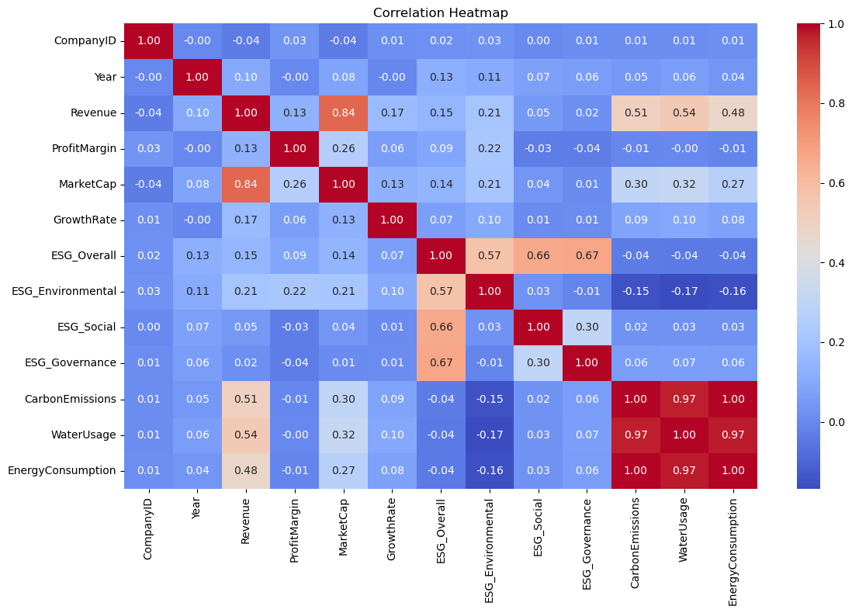
PREDICTIVE MODELING
from sklearn.model_selection import train_test_split
from sklearn.preprocessing import LabelEncoder, StandardScaler
from sklearn.metrics import classification_report, confusion_matrix
# Drop missing values
shivam.dropna(inplace=True)
# Encode categorical columns
cat_cols = ['Industry', 'Region']
label_encoders = {}
for col in cat_cols:
le = LabelEncoder()
shivam [col] = le.fit_transform(shivam[col])
label_encoders[col] = le
# Define features and target
X = shivam.drop(['Industry', 'CompanyName'], axis=1) # Drop text column
y = shivam ['Industry']
# Scale features
scaler = StandardScaler()
X_scaled = scaler.fit_transform(X)
# Split dataset
X_train, X_test, y_train, y_test = train_test_split(
X_scaled, y, test_size=0.2, random_state=42, stratify=y
)
from sklearn.linear_model import LogisticRegression
from sklearn.neighbors import KNeighborsClassifier
from sklearn.tree import DecisionTreeClassifier
from sklearn.ensemble import RandomForestClassifier, GradientBoostingClassifier
from sklearn.svm import SVC
from sklearn.naive_bayes import GaussianNB
models = {
'Logistic Regression': LogisticRegression(max_iter=1000),
'KNN': KNeighborsClassifier(),
'Decision Tree': DecisionTreeClassifier(),
'Random Forest': RandomForestClassifier(),
'SVM': SVC(),
'Naive Bayes': GaussianNB(),
'Gradient Boosting': GradientBoostingClassifier()
}
results = {}
for name, model in models.items():
model.fit(X_train, y_train)
y_pred = model.predict(X_test)
print(f"\n🔹 Model: {name}")
print(classification_report(y_test, y_pred))
cm = confusion_matrix(y_test, y_pred)
plt.figure(figsize=(6, 4))
sns.heatmap(cm, annot=True, fmt='d', cmap='Blues')
plt.title(f'Confusion Matrix - {name}')
plt.xlabel('Predicted')
plt.ylabel('True')
plt.tight_layout()
plt.show()
results[name] = model.score(X_test, y_test)
🔹 Model: Logistic Regression
precision recall f1-score support
0 0.89 0.88 0.88 232
1 0.99 0.88 0.93 216
2 0.76 0.86 0.81 226
3 0.82 0.73 0.77 242
4 0.97 0.86 0.91 234
5 0.66 0.87 0.75 212
6 0.89 0.67 0.77 190
7 0.82 0.89 0.85 234
8 0.90 0.94 0.92 214
accuracy 0.84 2000
macro avg 0.86 0.84 0.85 2000
weighted avg 0.86 0.84 0.85 2000
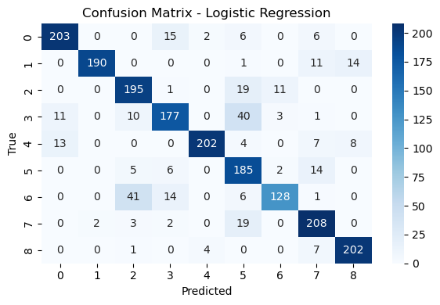
🔹 Model: KNN
precision recall f1-score support
0 0.66 0.77 0.71 232
1 0.87 0.86 0.87 216
2 0.81 0.89 0.85 226
3 0.81 0.82 0.82 242
4 0.69 0.71 0.70 234
5 0.68 0.72 0.70 212
6 0.92 0.85 0.89 190
7 0.79 0.76 0.77 234
8 0.70 0.54 0.61 214
accuracy 0.77 2000
macro avg 0.77 0.77 0.77 2000
weighted avg 0.77 0.77 0.77 2000
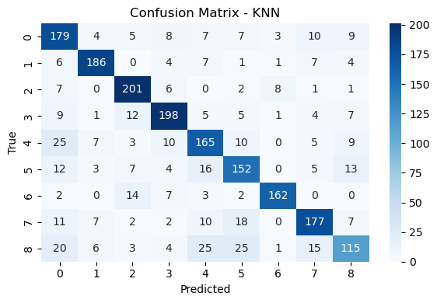
🔹 Model: Decision Tree
precision recall f1-score support
0 1.00 0.99 0.99 232
1 0.99 0.98 0.99 216
2 0.99 0.97 0.98 226
3 0.97 0.92 0.94 242
4 0.99 1.00 0.99 234
5 0.93 0.98 0.95 212
6 0.93 0.95 0.94 190
7 0.99 1.00 0.99 234
8 0.98 0.96 0.97 214
accuracy 0.97 2000
macro avg 0.97 0.97 0.97 2000
weighted avg 0.97 0.97 0.97 2000
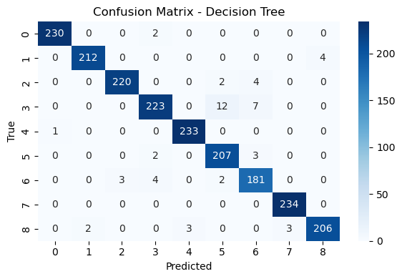
🔹 Model: Random Forest
precision recall f1-score support
0 1.00 1.00 1.00 232
1 1.00 1.00 1.00 216
2 1.00 1.00 1.00 226
3 0.99 1.00 0.99 242
4 1.00 1.00 1.00 234
5 0.99 0.99 0.99 212
6 1.00 0.99 0.99 190
7 1.00 1.00 1.00 234
8 1.00 1.00 1.00 214
accuracy 1.00 2000
macro avg 1.00 1.00 1.00 2000
weighted avg 1.00 1.00 1.00 2000
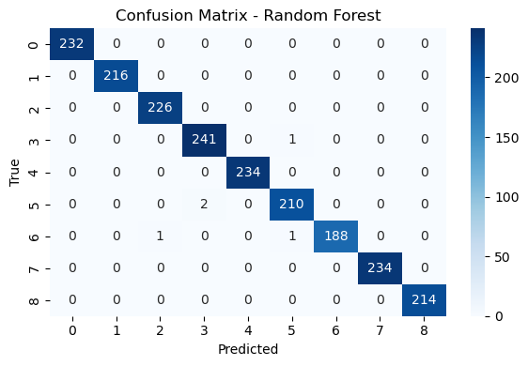
🔹 Model: SVM
precision recall f1-score support
0 0.61 0.60 0.60 232
1 0.99 0.85 0.92 216
2 0.78 0.82 0.80 226
3 0.69 0.67 0.68 242
4 0.75 0.59 0.66 234
5 0.55 0.74 0.63 212
6 0.89 0.77 0.83 190
7 0.65 0.82 0.73 234
8 0.74 0.65 0.69 214
accuracy 0.72 2000
macro avg 0.74 0.72 0.73 2000
weighted avg 0.73 0.72 0.72 2000
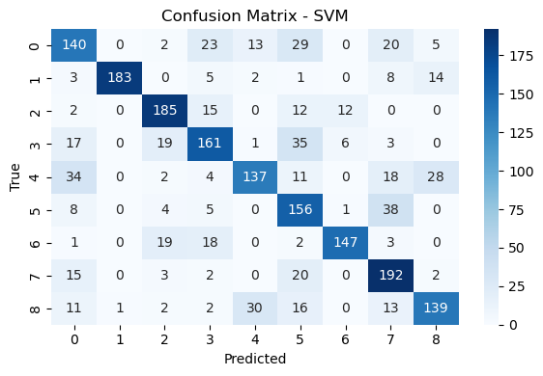
🔹 Model: Naive Bayes
precision recall f1-score support
0 0.64 0.59 0.62 232
1 0.95 0.57 0.71 216
2 0.63 0.87 0.73 226
3 0.67 0.37 0.48 242
4 0.45 0.28 0.35 234
5 0.52 0.91 0.66 212
6 0.79 0.38 0.51 190
7 0.55 0.75 0.63 234
8 0.51 0.65 0.57 214
accuracy 0.60 2000
macro avg 0.63 0.60 0.58 2000
weighted avg 0.63 0.60 0.58 2000
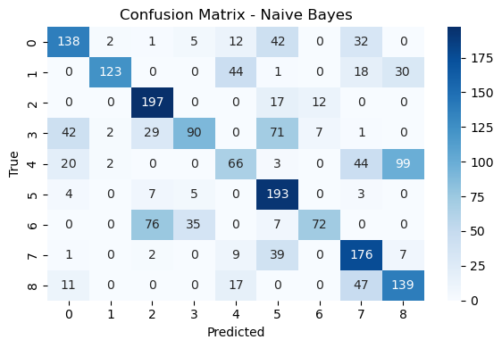
🔹 Model: Gradient Boosting
precision recall f1-score support
0 1.00 1.00 1.00 232
1 1.00 0.99 1.00 216
2 0.99 1.00 0.99 226
3 1.00 1.00 1.00 242
4 0.99 1.00 0.99 234
5 0.99 1.00 0.99 212
6 0.99 0.97 0.98 190
7 1.00 1.00 1.00 234
8 0.99 0.99 0.99 214
accuracy 0.99 2000
macro avg 0.99 0.99 0.99 2000
weighted avg 0.99 0.99 0.99 2000
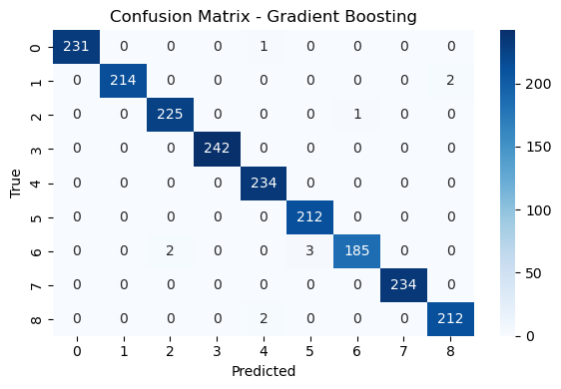
plt.figure(figsize=(10, 5))
sns.barplot(x=list(results.keys()), y=list(results.values()), palette='viridis')
plt.title("Model Accuracy Comparison")
plt.ylabel("Accuracy")
plt.xticks(rotation=45)
plt.ylim(0, 1)
plt.tight_layout()
plt.show()
C:\Users\gadar\AppData\Local\Temp\ipykernel_12400\1231151329.py:2: FutureWarning:
Passing `palette` without assigning `hue` is deprecated and will be removed in v0.14.0. Assign the `x` variable to `hue` and set `legend=False` for the same effect.
sns.barplot(x=list(results.keys()), y=list(results.values()), palette='viridis')
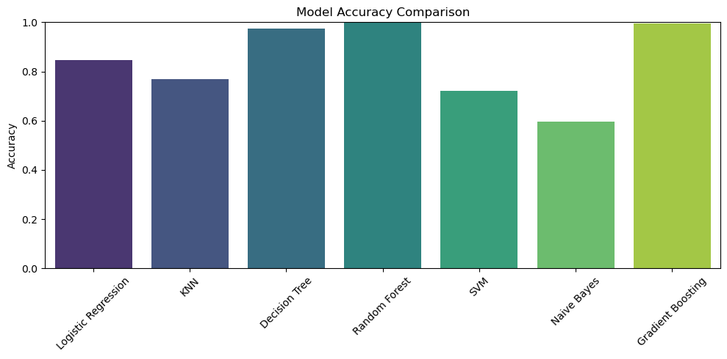
from scipy.stats import ttest_ind
# Choose two groups to compare
region_1 = shivam[shivam['Region'] == 'North America']['ProfitMargin']
region_2 = shivam[shivam['Region'] == 'Europe']['ProfitMargin']
# Run independent t-test (Welch's t-test)
t_stat, p_val = ttest_ind(region_1, region_2, equal_var=False)
print(f"T-statistic: {t_stat:.3f}, P-value: {p_val:.4f}")
if p_val < 0.05:
print("✅ Statistically significant difference in Profit Margin between regions.")
else:
print("❌ No significant difference in Profit Margin between regions.")
T-statistic: nan, P-value: nan
❌ No significant difference in Profit Margin between regions.
from sklearn.linear_model import LinearRegression
from sklearn.model_selection import train_test_split
import statsmodels.api as sm
from sklearn.metrics import mean_absolute_error, mean_squared_error, r2_score
# Features and target
X = shivam[['ProfitMargin', 'Revenue', 'CarbonEmissions']]
y = shivam['ESG_Overall']
# Train-test split
X_train, X_test, y_train, y_test = train_test_split(
X, y, test_size=0.2, random_state=42
)
# Model fitting
lr = LinearRegression()
lr.fit(X_train, y_train)
# Predictions
y_pred = lr.predict(X_test)
# Evaluation
print("Mean Absolute Error:", mean_absolute_error(y_test, y_pred))
print("Mean Squared Error:", mean_squared_error(y_test, y_pred))
print("R2 Score:", r2_score(y_test, y_pred))
# Optional: OLS summary from statsmodels
X_sm = sm.add_constant(X) # Add intercept
model = sm.OLS(y, X_sm).fit()
print(model.summary())
Mean Absolute Error: 12.77261791210895
Mean Squared Error: 252.0614963985363
R2 Score: 0.044295252102376725
OLS Regression Results
==============================================================================
Dep. Variable: ESG_Overall R-squared: 0.043
Model: OLS Adj. R-squared: 0.042
Method: Least Squares F-statistic: 148.3
Date: Thu, 17 Apr 2025 Prob (F-statistic): 5.00e-94
Time: 22:14:57 Log-Likelihood: -41616.
No. Observations: 10000 AIC: 8.324e+04
Df Residuals: 9996 BIC: 8.327e+04
Df Model: 3
Covariance Type: nonrobust
===================================================================================
coef std err t P>|t| [0.025 0.975]
-----------------------------------------------------------------------------------
const 52.8474 0.251 210.942 0.000 52.356 53.339
ProfitMargin 0.0972 0.018 5.518 0.000 0.063 0.132
Revenue 0.0003 1.78e-05 18.882 0.000 0.000 0.000
CarbonEmissions -4.522e-07 3.46e-08 -13.078 0.000 -5.2e-07 -3.84e-07
==============================================================================
Omnibus: 66.203 Durbin-Watson: 0.215
Prob(Omnibus): 0.000 Jarque-Bera (JB): 49.189
Skew: -0.069 Prob(JB): 2.08e-11
Kurtosis: 2.685 Cond. No. 8.72e+06
==============================================================================
Notes:
[1] Standard Errors assume that the covariance matrix of the errors is correctly specified.
[2] The condition number is large, 8.72e+06. This might indicate that there are
strong multicollinearity or other numerical problems.
import statsmodels.api as sm
# Step 2: Linear Regression - Predicting ESG_Overall from CarbonEmissions
X_lin = sm.add_constant(shivam['CarbonEmissions']) # Add intercept
model_lin = sm.OLS(shivam['ESG_Overall'], X_lin).fit()
pred_lin = model_lin.predict(X_lin)
# Print regression summary
print(model_lin.summary())
OLS Regression Results
==============================================================================
Dep. Variable: ESG_Overall R-squared: 0.002
Model: OLS Adj. R-squared: 0.001
Method: Least Squares F-statistic: 15.04
Date: Thu, 17 Apr 2025 Prob (F-statistic): 0.000106
Time: 22:15:22 Log-Likelihood: -41826.
No. Observations: 10000 AIC: 8.366e+04
Df Residuals: 9998 BIC: 8.367e+04
Df Model: 1
Covariance Type: nonrobust
===================================================================================
coef std err t P>|t| [0.025 0.975]
-----------------------------------------------------------------------------------
const 55.0851 0.163 337.127 0.000 54.765 55.405
CarbonEmissions -1.174e-07 3.03e-08 -3.879 0.000 -1.77e-07 -5.81e-08
==============================================================================
Omnibus: 72.199 Durbin-Watson: 0.214
Prob(Omnibus): 0.000 Jarque-Bera (JB): 50.883
Skew: -0.048 Prob(JB): 8.93e-12
Kurtosis: 2.664 Cond. No. 5.56e+06
==============================================================================
Notes:
[1] Standard Errors assume that the covariance matrix of the errors is correctly specified.
[2] The condition number is large, 5.56e+06. This might indicate that there are
strong multicollinearity or other numerical problems.
import statsmodels.api as sm
# Step 3: Logistic Regression - Predicting if ESG_Overall >= 75
shivam['HighESG'] = (shivam['ESG_Overall'] >= 75).astype(int) # Binary target
# Use CarbonEmissions as the predictor (you can add more later)
X_logit = sm.add_constant(shivam['CarbonEmissions']) # Add intercept
logit_model = sm.Logit(shivam['HighESG'], X_logit).fit(disp=False)
# Predict probabilities
logit_pred_prob = logit_model.predict(X_logit)
# Print model summary
print(logit_model.summary())
Logit Regression Results
==============================================================================
Dep. Variable: HighESG No. Observations: 10000
Model: Logit Df Residuals: 9998
Method: MLE Df Model: 1
Date: Thu, 17 Apr 2025 Pseudo R-squ.: 0.0003420
Time: 22:16:50 Log-Likelihood: -3443.0
converged: True LL-Null: -3444.2
Covariance Type: nonrobust LLR p-value: 0.1248
===================================================================================
coef std err z P>|z| [0.025 0.975]
-----------------------------------------------------------------------------------
const -2.0869 0.033 -62.314 0.000 -2.152 -2.021
CarbonEmissions -1.185e-08 8.65e-09 -1.370 0.171 -2.88e-08 5.1e-09
===================================================================================
plt.figure(figsize=(14, 6))
# Linear Regression Plot
plt.subplot(1, 2, 1)
plt.scatter(shivam['CarbonEmissions'], shivam['ESG_Overall'], alpha=0.5, color='blue', label='Actual ESG')
plt.plot(shivam['CarbonEmissions'], pred_lin, color='red', label='Regression Line')
plt.xlabel('Carbon Emissions')
plt.ylabel('ESG Overall Score')
plt.title('Linear Regression: Carbon Emissions vs ESG Score')
plt.legend()
plt.grid(True)
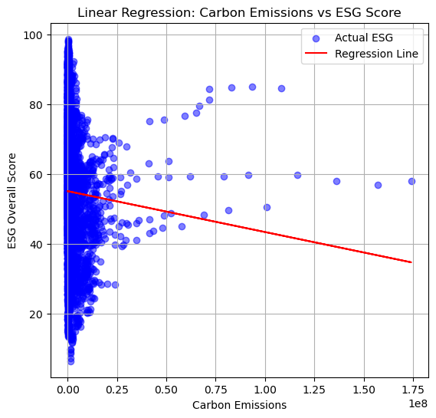
y_pred
array([55.15854489, 53.55975053, 52.85944291, ..., 54.13856884,
55.38858192, 53.36117953])
from sklearn.metrics import mean_absolute_error, mean_squared_error, r2_score
# Evaluation metrics
mae = mean_absolute_error(y_test, y_pred)
mse = mean_squared_error(y_test, y_pred)
r2 = r2_score(y_test, y_pred)
# Print results
print(f"📊 Evaluation Results:")
print(f"MAE : {mae:.3f}")
print(f"MSE : {mse:.3f}")
print(f"R² Score : {r2:.3f}")
📊 Evaluation Results:
MAE : 12.773
MSE : 252.061
R² Score : 0.044
🧠 Rating Classification (Logistic Regression)
Since the dataset doesn't include ROI, we created a new label Rating_Label to classify movies as:
- High: IMDB Rating ≥ 7.0
- Low: IMDB Rating < 7.0
Steps:
- Created the binary classification label
- Trained a Logistic Regression model
- Evaluated with accuracy, precision, and recall
# Classify companies as 'High' or 'Low' ESG
from sklearn.metrics import accuracy_score, precision_score, recall_score
shivam['ESG_Label'] = shivam['ESG_Overall'].apply(lambda x: 'High' if x >= 75 else 'Low')
from sklearn.preprocessing import LabelEncoder
le = LabelEncoder()
shivam['ESG_Label_Encoded'] = le.fit_transform(shivam['ESG_Label']) # High = 1, Low = 0
# Features and Target
X = shivam[['CarbonEmissions', 'Revenue', 'ProfitMargin']] # You can add more
y = shivam['ESG_Label_Encoded']
# Split
X_train, X_test, y_train, y_test = train_test_split(X, y, test_size=0.2, random_state=42)
# Train model
clf = LogisticRegression(max_iter=1000)
clf.fit(X_train, y_train)
# Predict
y_pred = clf.predict(X_test)
print("🔍 Classification Metrics")
print(f"Accuracy : {accuracy_score(y_test, y_pred):.3f}")
print(f"Precision: {precision_score(y_test, y_pred):.3f}")
print(f"Recall : {recall_score(y_test, y_pred):.3f}")
🔍 Classification Metrics
Accuracy : 0.907
Precision: 0.909
Recall : 0.997
y_pred = log_model.predict(X_test)
import numpy as np
# Sort values for smooth logistic curve
sorted_idx = np.argsort(shivam['CarbonEmissions'].values)
sorted_emissions = shivam['CarbonEmissions'].values[sorted_idx]
sorted_probs = logit_pred_prob.values[sorted_idx]
import matplotlib.pyplot as plt
plt.figure(figsize=(8, 5))
plt.plot(sorted_emissions, sorted_probs, color='darkorange', label='Logistic Curve')
plt.scatter(shivam['CarbonEmissions'], shivam['HighESG'], alpha=0.4, label='Actual Data')
plt.xlabel("Carbon Emissions")
plt.ylabel("Probability of High ESG")
plt.title("Logistic Regression Curve")
plt.legend()
plt.grid(True)
plt.show()
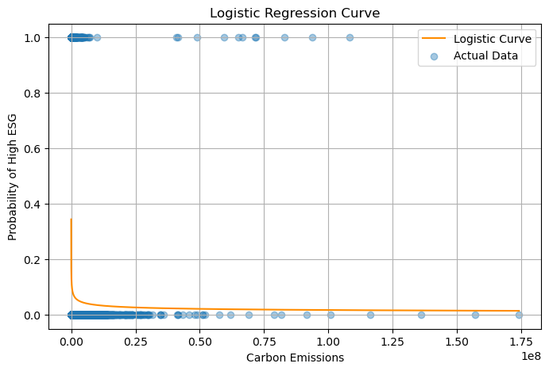
# Optional: Log-transform for better spread
shivam['CarbonEmissions_log'] = np.log1p(shivam['CarbonEmissions'])
# Binary label
shivam['HighESG'] = (shivam['ESG_Overall'] >= 75).astype(int)
# Feature and intercept
X_logit = sm.add_constant(shivam['CarbonEmissions_log'])
y_logit = shivam['HighESG']
# Logistic model
logit_model = sm.Logit(y_logit, X_logit).fit(disp=False)
logit_pred_prob = logit_model.predict(X_logit)
# Sort for smooth curve
sorted_idx = np.argsort(shivam['CarbonEmissions_log'].values)
sorted_x = shivam['CarbonEmissions_log'].values[sorted_idx]
sorted_probs = logit_pred_prob.values[sorted_idx]
# Plot
plt.figure(figsize=(12, 5))
plt.scatter(shivam['CarbonEmissions_log'], shivam['HighESG'], alpha=0.5, color='purple', label='Actual (0/1)')
plt.plot(sorted_x, sorted_probs, color='green', linewidth=2.5, label='Logistic S-Curve')
plt.xlabel('Log of Carbon Emissions')
plt.ylabel('Probability of High ESG')
plt.title('Logistic Regression S-Curve: Carbon Emissions vs High ESG')
plt.legend()
plt.grid(True)
plt.tight_layout()
plt.show()
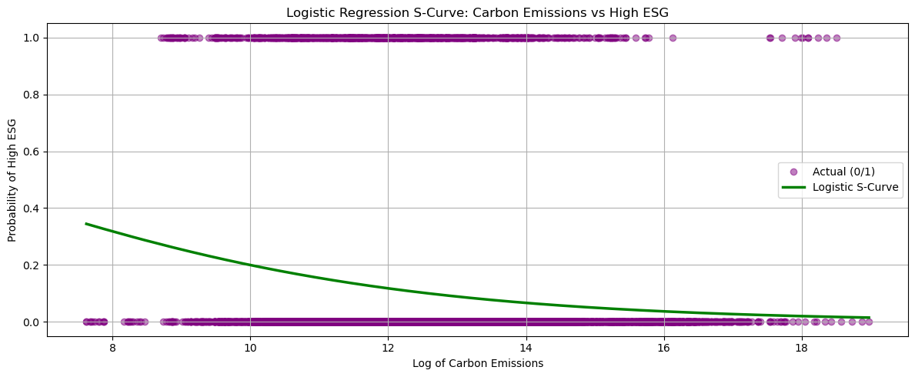
plt.tight_layout()
plt.show()
<Figure size 640x480 with 0 Axes>
y_pred
array([0, 1, 1, ..., 1, 1, 1])
# Step 5: Evaluation
print("Accuracy:", accuracy_score(y_test, y_pred))
print("Precision:", precision_score(y_test, y_pred))
print("Recall:", recall_score(y_test, y_pred))
Accuracy: 0.9068181818181819
Precision: 0.9091738931994523
Recall: 0.996996996996997
## 📏 Model Evaluation
We evaluate our `Rating_Label` classification model using:
- ✅ Confusion Matrix
- ✅ Accuracy Score
- ✅ Precision & Recall
These metrics help measure how well the model distinguishes between "High" and "Low" rated movies.
from sklearn.metrics import confusion_matrix, ConfusionMatrixDisplay
import matplotlib.pyplot as plt
# Confusion Matrix
cm = confusion_matrix(y_test, y_pred)
disp = ConfusionMatrixDisplay(confusion_matrix=cm, display_labels=label_encoder.classes_)
# Plot
disp.plot(cmap='Blues')
plt.title("Confusion Matrix")
plt.grid(False)
plt.show()
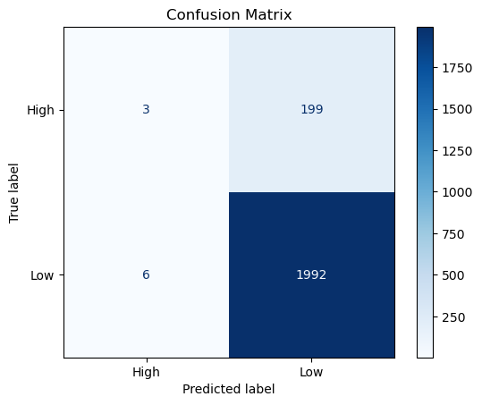

🔚 Final Conclusion In this project, we explored a corporate ESG dataset to understand how different company features — such as Carbon Emissions, Revenue, Profit Margin, and Industry/Region — influence their overall ESG performance.
🎯 Project Goals: ESG Score Prediction: We used Linear Regression to predict a company’s ESG score based on numeric financial and environmental variables.
ESG Classification: We applied Logistic Regression to classify companies as High ESG performers or not, based on the same features.
🛠️ Workflow Highlights: ✅ Collected, cleaned, and preprocessed the ESG dataset
✅ Performed rich Exploratory Data Analysis (EDA) to uncover trends and outliers
✅ Used Hypothesis Testing to compare ESG performance between different industries
✅ Built and evaluated both regression and classification models
📌 Key Takeaways: Companies with lower Carbon Emissions and stronger Profit Margins tend to have higher ESG scores
Industry and Region also influence ESG performance, suggesting regulatory or market-driven effects
ESG classification models can help identify companies likely to be sustainable leaders
Combining financial data with sustainability metrics unlocks powerful business insights
✅ Final Thoughts This project connected classroom concepts like statistics, data cleaning, visualization, regression, and classification to a real-world sustainability challenge.
By analyzing ESG data, we developed a deeper understanding of how environmental impact and financial performance intersect — an increasingly critical area for investors, regulators, and business leaders.
🌍 Data Science empowers responsible decision-making — building a future that’s both profitable and sustainable.

